MYSQL PROJECT

Name : Sharayu Mitesh Bandre

PROJECT TITLE

EMPLOYEE PAYROLL MANAGEMENT SYSTEM

SR.NO | CONTENT
1. | SQL SUMMARY
2. | LIST OF ENTRIES
3. | DESCRIBE TABLES
4. | SUBQUERYS
5. | JOINS
6. | VEIWS

STRUCTURED QUERY LANGUAGE (SQL) :

● SQL was earlier known as SEQUEL.
● It is used to communicate with the Database.
● This is a standard language used to perform tasks such as retrieval, updation, insertion and deletion of
data from a database.

-------------------------------------------------------------------------------------------------------------------
1. Data:
Data is defined as facts or figures, or information that's stored in or used by a computer.
Ex: Information collected for a research paper, an Email, etc.

2. Database:
Database is nothing but an organized form of data for easy access, storing, retrieval and managing of data.
This is also known as structured form of data which can be accessed in many ways.
Example: School Management Database, Bank Management Database.

3. DBMS:
A Database Management System (DBMS) is a program that controls creation, maintenance and use of a
database. DBMS can be termed as File Manager that manages data in a database rather than saving it in file
systems.

4.) RDBMS:
RDBMS stands for Relational Database Management System. RDBMS store the data into the collection of
tables, which is related by common fields between the columns of the table. It also provides relational
operators to manipulate the data stored into the tables.
Example: SQL Server.

5.) Tables & Fields:
A table is a set of data that are organized in Columns and Rows. Columns can be categorized as vertical,
and Rows are horizontal. A table has specified number of column called fields but can have any number of
rows which is called record.
Example:
Table Name : Employee.

Fields: Emp ID, Emp Name, Date of Birth.
Data: 201456, David, 11/15/1960.

ABSTRACT :

The “Payroll Management System” is designed to automate the existing manual system using computerized equipment and cutting-edge computer software, meeting client’s needs so that their valuable data and information can be stored for a longer period with easy access and manipulation. The necessary software is readily available and simple to use. This software allows users to keep track of and see computerized records without having to make duplicate entries. The project explains how to handle user data for optimal efficiency and better customer service.
The payroll management system is a web-based program that can be used by any firm to manage the records of its employees. The Payroll Application was created with the goal of keeping track of numerous employees, their salary,must be given to the company’s employees. There will be an entry (a unique ID) for every employee of any company. The number of days will be submitted based on the date of joining and the date on which the salary is produced. Basic compensation will be determined by the employee’s position and department.

MODULES :

1. Employee Information Management:

This module provides a consolidated database for application tracking, employee demographics, compensation and benefit options, time tracking, and more. It’s also the central location for all of your personnel data, including the most up-to-date statistics on your organization’s hiring and retention patterns.

2. Department :

Department details maintains the data of the all the possible departments an employee can belong to.

3. Salary Monitoring:

Very important to keep this data which will help not only the managers and the HR to keep a track of the employee salaries but also help the company or its board to analyze what amount they are spending on a particular employee of a particular company.

4. Projects :

In order to be successful company should be involved in various projects, so they also need to maintain the record of the salaries each employee is being paid for a particular type of project he/she is working on.

STRUCTURE OF TABLES

TABLE NAME : EMPLOYEE

This table contains the personal details of all the employees such as their name, age, department name,age,hire date,city and salary.

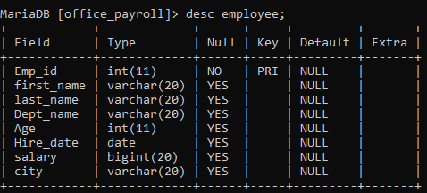

TABLE NAME : DEPARTMENT

This table contains the details of all the departments such as department id, department name.

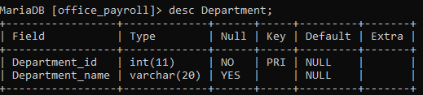

TABLE NAME : PROJECT

This table contains the details of all the projects such as name of that project,start date of that project and end date of that project as well as details of those employee who are working on that particular project.

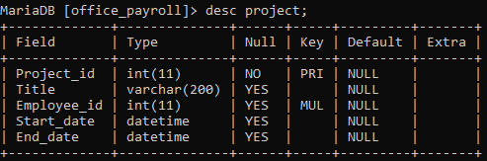TABLE NAME : ATTENDANCE

This table contains the details of attendance of all the employees and working hours.

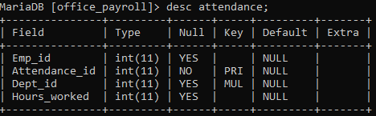
------------------------------------------------------------------------------------------------
CONTENTS OF TABLES

EMPLOYEE :
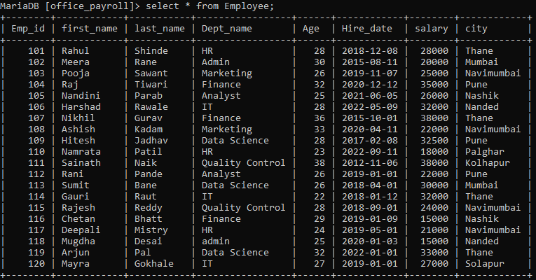
DEPARTMENT :

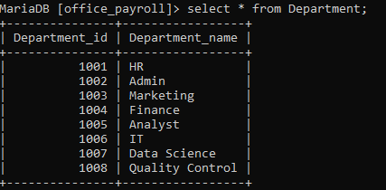

PROJECT :

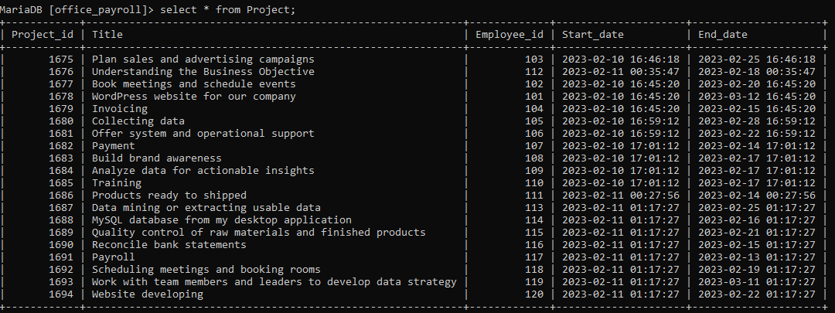

ATTENDANCE :

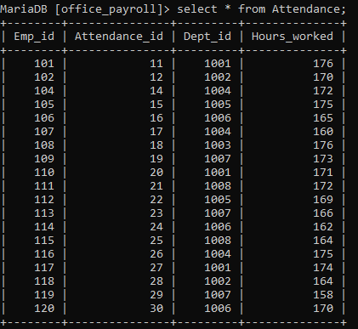

SUBQUERIES

● A subquery is a SELECT statement which is used in another SELECT statement.
● Subqueries are very useful when you need to select rows from a table with a condition that depends on
the data of the table itself.
● You can use the subquery in the SQL clauses including WHERE clause, HAVING clause, FROM
clause etc.
● The subquery can also be referred as nested SELECT, sub SELECT or inner SELECT.
● In general, the subquery executes first and its output is used in the main query or outer query.
Guidelines for using a subquery:
● Enclose subqueries in ( ).
● Place subqueries on the right side of the comparison operator.
● Do not add an ORDER BY clause to a subquery.
● Use single-row operators with single-row subqueries. (<,>,<=,>=,<>)
● Use multiple-row operators with multiple-row subqueries (IN, ANY, ALL).
● We can write a sub query with in a subquery.

1.Find the details of employee whose department same as harshad and who are earning salary less than harshad ?

MariaDB [office_payroll]> select * from employee where dept_name=(select dept_name from employee where First_Name="Harshad") AND salary < (select salary from employee where First_name="Harshad");

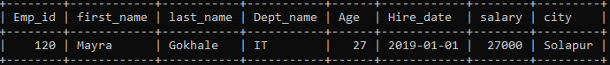

2.Display senior employee.

MariaDB [office_payroll]> select * from employee where hire_date=(select min(hire_date) from employee);

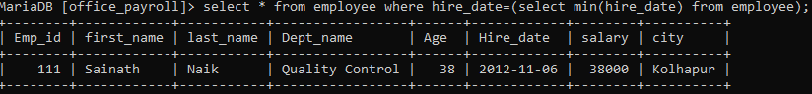

3.Display Employee name who is associated with project "word press website for our company".

MariaDB [office_payroll]> select First_name,Last_name from employee where emp_id = (select employee_id from project where title="wordpress website for our company");

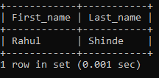

JOINS

A SQL Join statement is used to combine data or rows from two or more tables based on a common field between
them.

* Different types of Joins are:

1. INNER JOIN
2. LEFT JOIN
3. RIGHT JOIN
4. FULL JOIN (Using ‘UNION’ in mysql)
5. CROSS JOIN
6. SELF JOIN

1. Display all employee and on which particular project they are associated.

MariaDB [office_payroll]> select employee.Emp_id,employee.first_name,employee.last_name,project.title from employee INNER JOIN project on employee.Emp_id=project.Employee_id;

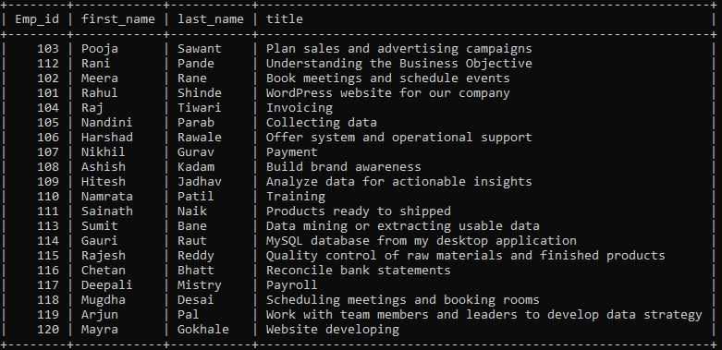

VIEWS

● Views in SQL are kind of virtual tables.
● A view also has rows and columns as they are in a real table in the database.
● We can create a view by selecting fields from one or more tables present in the database.
● A View can either have all the rows of a table or specific rows based on certain condition.

1.Create a table for employees and department name where salary is less than 25000.

MariaDB [office_payroll]> create view emp_view as select first_name,Dept_name from employee where salary < 25000;

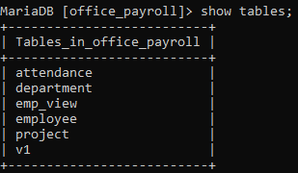

MariaDB [office_payroll]> select * from emp_view;

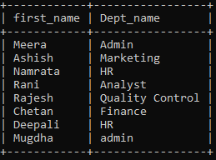
2.Create a table for employee department vise salary details and there association with project.

MariaDB [office_payroll]> create view v1 As select e.first_name,e.dept_name,e.salary,p.title from employee e,project p where e.emp_id=p.employee_id;

MariaDB [office_payroll]> select * from v1;

